**Road Controlling Authorities Forum 8** August 2014

**Background**

The RCA forum was established in partnership with Local Government NZ (LGNZ) by Transit NZ around 1989, to ensure that knowledge was not lost as deregulation of the industry and the contracting out of physical and professional services work started.

Then Transit NZ and LGNZ provided co-chairs for the forum and this and partnership continues today. Current co-chairs are Mayor Ross Patterson, Mayor of Western BoP, appointed by LGNZ, and Kaye Clark, appointed by NZ Transport Agency. The forum activities are funded through subscriptions from 69 member organisations based on their size, determined in the case of local authorities by population. The Department of Conservation is also a member organisation. The Transport Agency contributes a subscription and also significant staff time to organise the forums.

**Purpose**

The forum is the only knowledge community of significant road infrastructure owners and operators. It’s where new ideas and major changes are discussed and rolled out.

It focuses on capturing, growing and sharing knowledge, and promoting best practice standards, guidelines and policies that can be used by member organisations.

In the early days working parties were established and produced policies, guidelines and contributed to much of today's best practice. More recently this role has become more one of connecting practitioners, researchers and industry groups. Working groups continue, the forum is active in research and guidelines, and it also provides members who can participate in wider industry research and policy/standards development.

Three forums are held each year. Current numbers range between 45-60. The largest forums have attracted more than 100.

The one-day forums are traditionally held in Wellington but “away” venues have been trialled in Christchurch and Auckland preceded by a study tour day.

For more details on the forum go to www.rcaforum.org.nz

**Looking ahead**

The RCA Forum has been keeping roading authorities up to date for 25 years, and wants to be a viable and relevant source of information and knowledge for the next 25 years. Please take time to complete the attached feedback form – whether you attended the latest forum or not – as your comments will help shape the organisation’s future.

**Current executive:**

Co-chairs: Kaye Clark and Ross Paterson. Also: Dave Jane (DOC), Andrew Scoggins (Auckland Transport), Tommy Parker (NZTA), Mike Reid (Local Govt NZ), Murray Hasler (Gore District Council),   
Jim Paterson (Western Bay District Council), Debbie Bryant (NZTA), Stephen Griffin, (Buller District Council), Warren Furner (Ruapehu District Council).

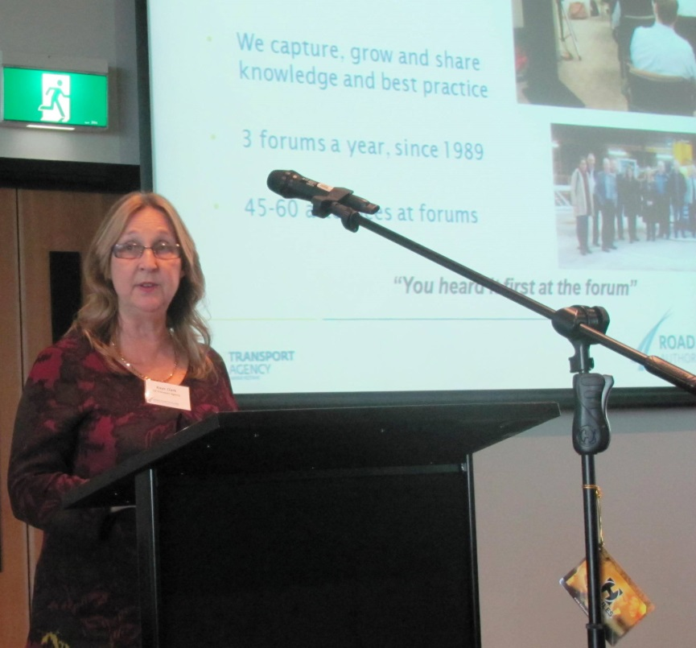

**Co-chair Kaye Clark from the Transport Agency at this month’s meeting**.

**Highlights from 8 August 2014 Forum:**

**Network Outcome Contracts** – NZTA’s Niclas Johansson spoke on the new way of managing road assets  
and improving service delivery. Similarly there was a conversation around the **One Network Road   
Classification**, where again it’s about service and performance measuring, from Vaughn Crowther   
of Rationale and NZTA’s Lynley Hutton.



The Transport Agency’s approach to the new zero harm legislation was explained by Martin McMullan,   
while the agency’s Rob Bullick showcased a Safe System demonstration project aimed at improving   
motorcycling safety.



There was a more technical flavour before lunch with a presentation on automated traffic safety assessment processes by MWH’s Shane Turner, and the latest level crossing safety improvement ideas from KiwiRail’s Brett Williams.

The feature session saw Auckland City’s CE Stephen Town and GM for strategy and planning Peter Clark speak frankly about that city’s transport challenges and solutions.

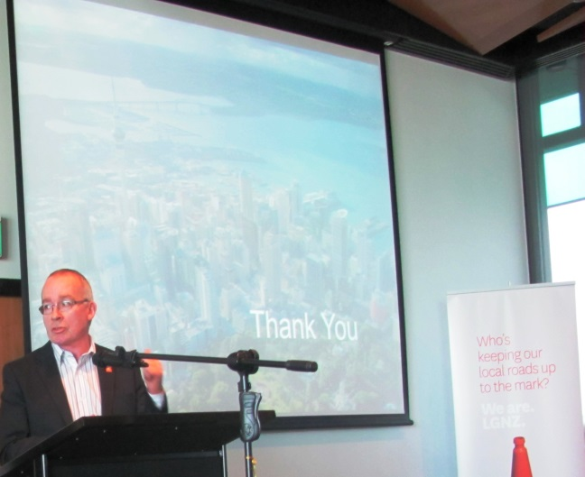

**Auckland Council CE Stephen Town talking about Auckland issues.**

The Transport Agency’s Bernie Cuttance and Julian Chisnall shone the light on the huge advantages   
and growing use of LED street lighting and the Ruapehu and Wairoa district councils talked about the   
impact of heavy vehicles on local roads and the need to establish a special interest working group.

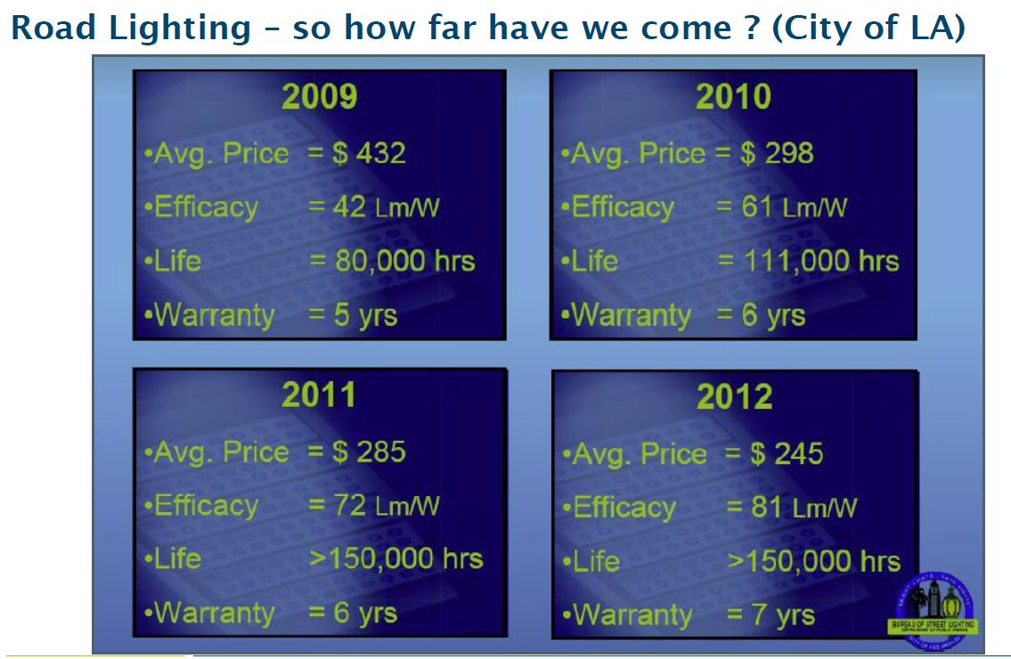

The day finished with an explanation of the work of Local Government NZ’s EquiP – which supports councils’ governance, management and performance – by LGNZ’s Steven Finlay.

**The August presentations will be loaded on the website: www.rcaforum.org.nz**

**See you at the next Forum – in Wellington on 28 November 2014**