File No:1082947 v1

TO | Sandi Morris, Gerry Dance
FROM | Heather Liew
DATE | 14 February 2014

SUBJECT | Proposal for Sharrow Marking Trial

1 Introduction

Auckland Transport has taken a lead role in investigating the potential use of Sharrow markings and additional on-road Cycle Lane Marking ‘LANE’ within New Zealand as an additional tool to support the existing cycle infrastructure treatments and wider network.

Palmerston North City Council has agreed to participate in the trial process by undertaking a similar investigation. The methodology used will be similar to Auckland Transport’s to produce comparable results and complement the research being undertaken in Auckland.

1.1 Sharrow Signs

The Auckland Transport states that the purpose of a Sharrow is to indicate a shared environment for cyclists and motorists. Sharrows increase the visibility of cyclists to motorists, and reinforces that the carriageway is a place for cyclists. The Sharrow is to help position cyclists on the road, provide adequate space for cyclists to stay clear of hazards such as car doors and stormwater grates and can be used as part of a way finding strategy to mark routes for cyclists.

The selection of routes for Sharrows should be based on routes that are logical, direct, connected, convenient and accessible. The routes must provide minimal delay or disruption to traffic flows. A safe crossing must be provided at intersection.

The use of Sharrow is applied to the following conditions:

- low volume ( Collector or local roads with AADT of less than 10,000 vehicles per day)
- low speed (50km per hour posted speed limit)
- the operational characteristics of the carriageway such as available width, terrain and vehicle composition

1.2 Additional On-road Cycle Lane Marking ‘LANE’

The current cycle symbol used within a cycle lane legally means that the lane becomes a special vehicle lane exclusive for cyclists and is illegal for use by motorists. In order to distinguish the difference between the shared use and exclusive use of the cycle symbol, it is proposed that the word ‘lane’ be added to cycle lanes. This will also be trialled in conjunction with the Sharrows.

1.3 Marking design

The Sharrow marking design will be based on the cycle symbol used in NZ supplemented with two chevron arrow markings as shown on Figure 1 & 2. The proposed Sharrow markings will be marked with white paint with skid resistant properties.

The proposed Sharrow marking is shown in Figure 1 & 2 below.

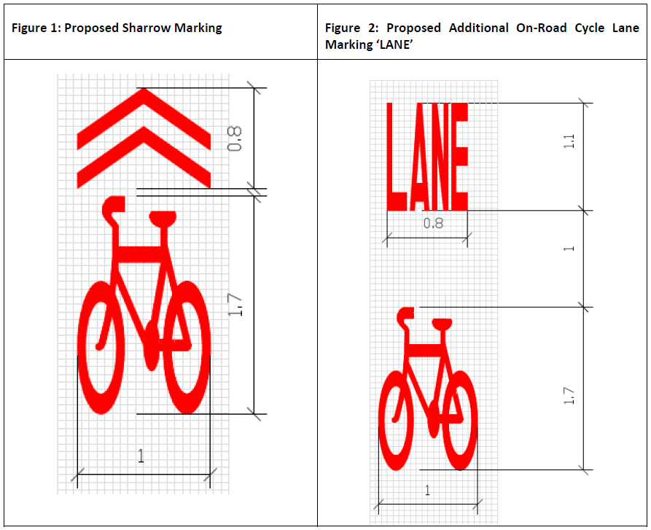
Source: 2014, Auckland Transport “Proposed Trial of Sharrow and Cycle Lane Markings: Application Report

2 Proposed Trial Sites

Possible trial sites being considered for the Sharrow marking trial in Palmerston North are as follows:

Sites | Location
1 | Park Road
2 | Russell Street & Grey Street

These sites have been selected based on low vehicle flows and its road environment characteristics similar to the sites proposed for the trial in Auckland. Cycle route connectivity between the Sharrow and cycle lane marking sites were also considered as part of the site selection.

The Cycle ”Lane” markings are trialled on Ruahine Street.

The location of the selected trial sites are shown in Figure 3.

Figure 3 Locations of Trial Sites

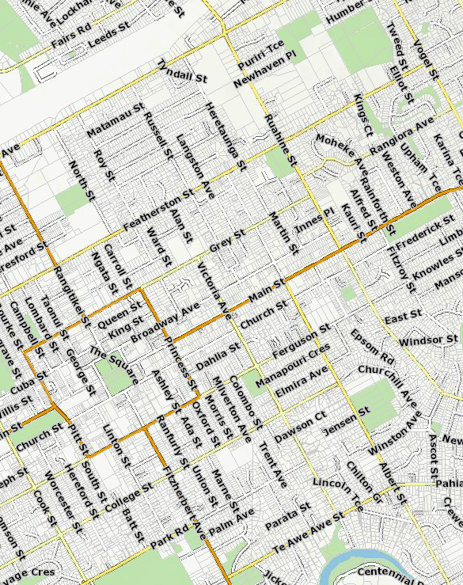
Site 2
“Lane” Marking Trial
Site 1

2.1 Sharrow Marking Options

2.1.1 Park Road

Park Road is a collector road with an AADT of approximately 3,720 vehicles per day. This road feeds into main cycling route such as Fitzherbert Ave and Victoria Ave. This road provides a link to key trip generators such as Palmerston North Normal Intermediate, College Street Normal School, Palmerston North Girls High and residential areas of Hokowhitu and Terrace End. The location of the key land uses are as shown in Figure 4.

There is an estimated 99 cyclists* using this route per day. At the time of survey the intersection of Park Road and Fitzherbert Ave was undergoing a construction works.

Table 1 Characteristics of Park Road

Criteria | Description
Road Type | Collector Road
Extent of Trial Site | Between Fitzherbert Ave and Victoria Ave
Cycle Network Status | This route is not part of cycle network.
Average Annual Daily Traffic Volume | 3,720 vehicles per day (estimated from RAMM)
Key adjacent land uses | College Normal Intermediate and residential properties
Typical Cross section (approx.) | - 3.7m footpath & grass berm  - 12.4 m wide kerb to kerb corridor  - Unrestricted parking the both sides; restricted P20 and P60 in front of dairy at the corner of Marne Street and Park Road

Figure 4 Key Land Uses within the vicinity of Park Road

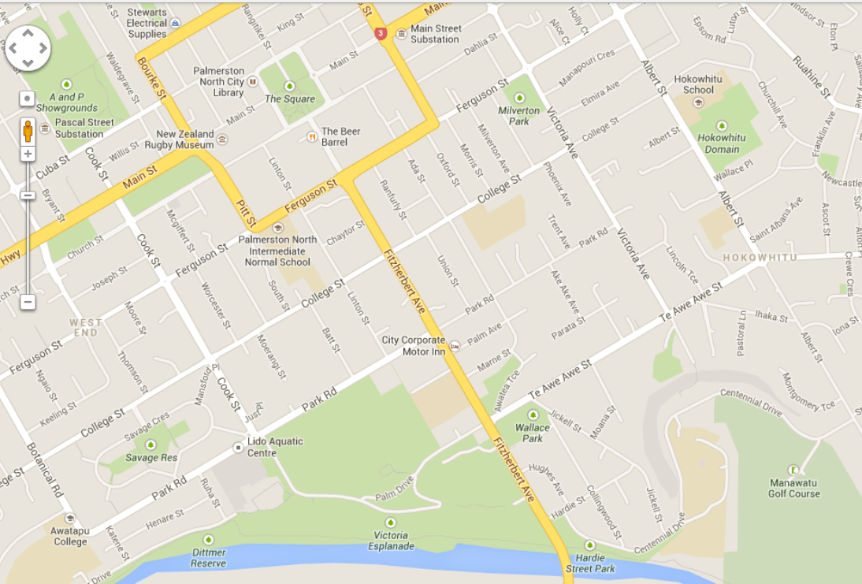
City Centre
To Massey University
Key:
1 – College Street Normal School
2 – Palmerston North Girls High
3 – Plaza Shopping Mall
4 – Palmerston North Intermediate Normal School
2
4
1
3
Source: Google Map 2014

Figure 5 View of Park Road in the Westbound

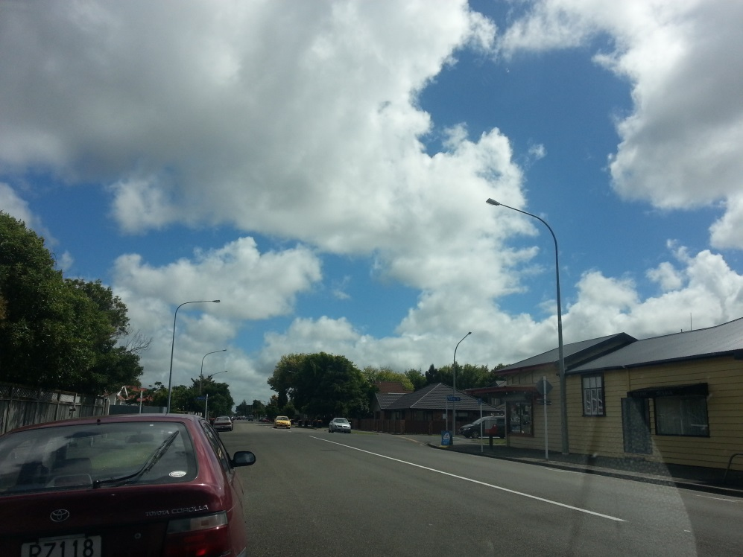

2.1.2 Russell Street - Grey Street

Russell Street is a Local Road with an AADT of approximately 2,700 vehicles/ day in front of no.107. The kerb to kerb width of 11.0 - 12.5m provides adequate width for parking on both sides of the road, Sharrow markings and traffic lanes. Russell Street Primary School, which is located at the northern end of this road, is the major contributor of cyclists on this street. There is an estimated 120 cyclists between Rongopai Street and Florence Ave that originated from smaller feeder roads such as Florence Ave and Rongopai Street. The number of cyclists using the mid-section and south of Russell Street was not surveyed because of construction works at the intersection of Russell Street and Featherston Street.

The Sharrow Markings on Grey Street is proposed from Albert Street to Ruahine Street. There are existing cycle facilities on Grey Street which ends at the intersection of Albert Street. Providing the proposed Sharrow Markings will complete cycle network and link it to the cycle lanes on Ruahine Street. The AADT of Grey Street 7,081 vehicles per day.
Table 3 Characteristics of Russell and Grey Street

Criteria | Russell Street | Grey Street
Road Type | Local Road | Collector Road
Extent of Trial Site | Between Featherston Street and Tremaine Ave | Between Heretaunga Street and Ruahine Street
Cycle Network Status | This route is not part of cycle network. | This route is not part of cycle network. The cycle network on Grey Street ends at Albert Street. Providing Sharrow markings will extend the cycle facilities from Albert Street to Ruahine Street, where cycle lanes are available.
Average Annual Daily Traffic Volume | 2,700 vehicles per day measured between Featherston Street and Grey Street (2013) | 7,081 vehicles per day (2012)
Key adjacent land uses | In proximity to Palmerston North Hospital, Russell Street School | In proximity to Palmerston North Hospital, St Mary’s School and Ross Intermediate
Typical Cross section (approx.) | - 1.7m-1.8m footpath 2.0m grass berm(Featherston Street- Grey Street)  12.6m corridor-corridor (Titoki St- Featherston Street)  - 1.7-1.8m, 2.5 grass berm, 11m  Carriageway (Bamberry and Grey St)  - Unrestricted parking on both sides | - 3.7m footpath  - 12.5m wide kerb to kerb corridor  - Unrestricted parking on both sides

Figure 6 Key Land Uses within the Vicinity of Russell Street

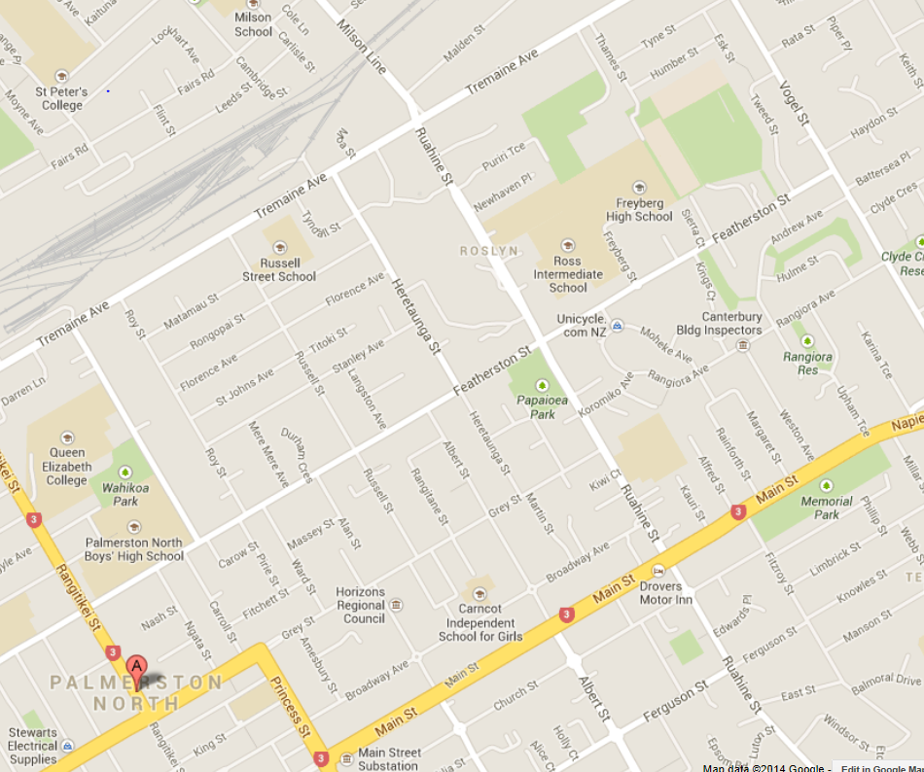
4
Key:
1 – Russell Street School
2 – Terrace End School
3 – Palmerston Boys’ High School
4 – Palmerston North Hospital
3
2
1
Source: Google Maps 2014

Figure 7 View of Russell Street in the Southbound Direction

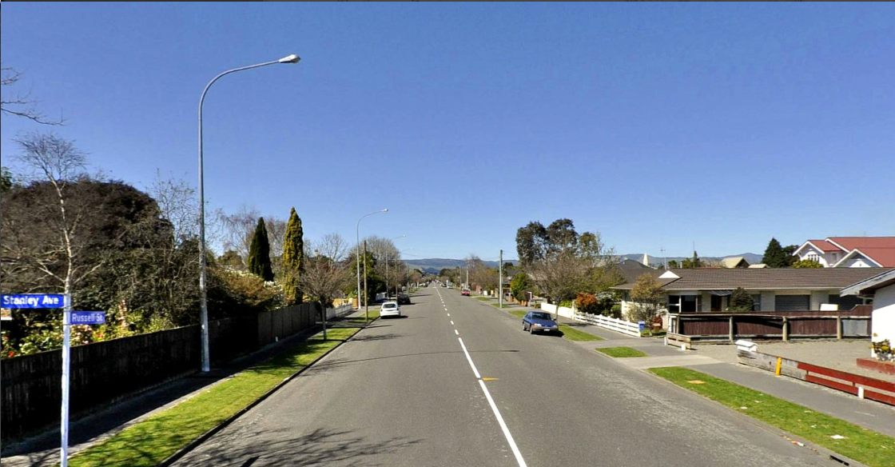

Figure 8 View of Grey Street in the Westbound Direction

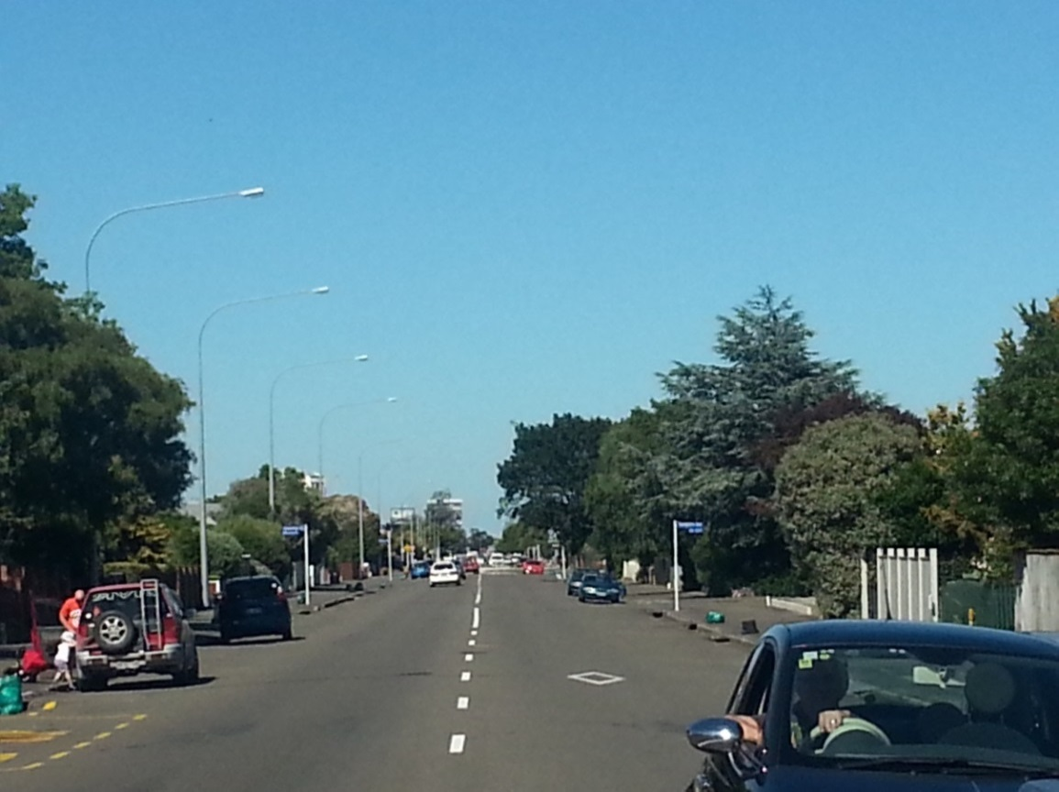

2.2 Cycle Lane on Ruahine Street

Along with the Sharrow markings placed on Russell Street, the proposed cycle lane symbol will be trialled on Ruahine Street. Ruahine Street is a Minor Arterial with an AADT of 17,000 vehicles per day. There is existing cycle lanes on both directions. There is connectivity between the cycle facilities on Russell Street and Ruahine Street.

Table 4 Characteristics of Ruahine Street

Criteria | Ruahine Street
Road Type | Minor Arterial
Extent of Trial Site | Between Tremaine Ave and Grey Street
Cycle Network Status | This route is part of cycle network. Existing cycle lanes are available.
Average Annual Daily Traffic Volume | 17,000 vehicles per day (2013)
Key adjacent land uses | In proximity to Palmerston North Hospital, St Mary’s School and Ross Intermediate

Figure 9 View of Ruahine Street in the Northbound Direction

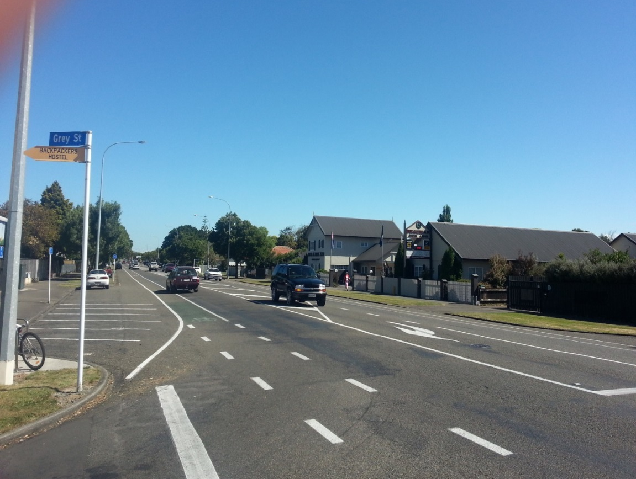

3 Methodology

The assessment of the Sharrow marking trial shall be in accordance with the proposed methodology used in the Auckland Transport Sharrow marking trials. It involves measuring cyclist lateral tracking, vehicle speed, vehicle counts and road user interaction four weekdays and one weekend.

3.1 Pre-trial Monitoring

Prior to marking the Sharrows on the selected sites, existing road user positioning, road user interaction, traffic volume and speed will be measured and monitored over four weekdays and one weekend. These will be measured using:

- Video recording: to determine the positioning of road users and interaction of road users within the road space, prior to the Sharrow markings being installed. This data will be manually reviewed.

- Tube counters: to determine the existing speed and traffic volume at the selected before implementation of the Sharrow markings.

The road will be marked at 0.5m intervals across the width of the road as a reference points to determine road users’ positioning within the road corridor. Data will be assessed according to the criteria outlined in Section 4.

Consultation will be undertaken at this stage to inform stakeholders and local user groups of the trial. Refer to Section 5 for more details of the consultation process.

3.2 Trial Implementation

The Sharrow markings will be installed at the trial locations for two months prior to data collection being undertaken. Video recording and tube counters will be undertaken similarly to the data collected in the pre-trial phase. The assessment criteria will be elaborated in Section 4.

Roadside interviews will be undertaken to determine cyclist and motorist perception of the Sharrow markings. The details of the roadside interviews will be further discussed in Section 5.

4 Proposed Assessment

4.1 Road User Positioning

Video recording will be used to assess the effect of Sharrow markings on the position of road users before and after its implementation. Prior to video recording, the road will be marked at 0.5m intervals across the width of the road as a reference points to determine road users’ positioning. The following data will be captured through observing the video footage and manual processing:

- Distance between bicycles and parked motor vehicles (tyre to tyre).
- Distance between bicycles and the kerb at the edge of the road (tyre to kerb) where there was no parking
- Distance between bicycles and passing motor vehicles (tyre to tyre).
- Distance between motor vehicles in the travel lane and parked motor vehicles (tyre to tyre) or to the kerb (tyre to kerb) when no bicycles were present.

4.2 Road User Interaction

Video recording will be used to assess road user interaction in accordance with the approach used by Auckland Transport. In the assessment, cyclists and motorist interactions will be observed and classified by types and severity as shown in Tables 5 and 6 below.

Table 5: Cyclist Interaction severity chart Interaction Severity | Description
no incident | Cyclist does not need to alter course or speed. The cyclist experiences no apparent effect as a result of the interaction
minor adjustment required | Cyclist alter course slightly, gently brakes or alters pedalling rhythm to allow for a comfortable passing distance.
major adjustment required | Cyclist needs to significantly alter course or adjust speed to avoid collision.
near collision | A rapid change of course or speed is required by the cyclist, motorist or both parties to avoid imminent collision
collision | physical contact between parties
Table 6: Motorist Interaction categories | Description
follows or leads patiently | Motorist follows or leads cyclist patiently, giving good room and not accelerating or braking rapidly or swerving
follows impatiently or aggressively | Motorist may follow the cyclist at an uncomfortable close distance and express aggressive driving behaviour
overtakes successfully | Motorist overtakes cyclist successfully, giving good clearance and without any obvious intimidating behaviour
overtakes successfully but aggressively | Motorist overtakes cyclist successfully but does so in an aggressive or intimidating manner
fails to overtake | motorist attempts to overtake, but fails to do so and instead waits patiently behind the cyclist
fails to overtake aggressively | motorist attempts to overtake in an aggressive or intimidating manner, but fails to do so
Car stationary / queue | motorist is stationary in a queue of traffic
Source: 2014, Auckland Transport “Proposed Trial of Sharrow and Cycle Lane Markings: Application Report

4.3 Vehicle Speed & Traffic Volumes

Tube counters will be placed before and after the trial to determine if Sharrow markings will have any impact on vehicle speeds and traffic volumes.

5 Consultation

As part of the trial, consultation will be undertaken with various stakeholders, organisations and local community groups so that they are kept informed of the Sharrow markings trial and have the opportunity to provide feedback on the project.

It is proposed that the following parties be consulted regarding the Sharrow markings trial:
- Palmerston North based cycle advocates and bicycle user groups such as Sustainable Manawatu, Bike Manawatu, Cycle Awareness Manawatu
- Palmerston North City Council
- The Automobile Association
- NZTA
- Local schools
- Palmerston North Police

6.1 Consultation Action Plan

6.1.1 Internal
Ongoing | Inform and seek approval from Traffic Operations, Parking, Traffic Systems, Road Maintenance, Corridor Access and Road Safety regarding trial

6.1.2 External
Ongoing | Meetings with identified stakeholders as required and agreed
One month before trial | Email/ letter to local boards, cycling groups and stakeholders regarding Sharrow trial. The letter will include:  - Information regarding the trial and its purpose  - Timeframe of trial  - Location of the trial areas  - Information on how to provide feedback and the type of feedback required.  The timeframe of 8 weeks given to provide feedback.
 | Advertise the Sharrow Marking Trial on Palmerston North City Council’s Facebook page and website.
Three weeks before the trial | Letter drop to household within the 100m radius of the trial area. The letter will include:  - Information regarding the trial  - Timeframe of trial  - Location of the trial areas  - Information on how to provide feedback and the type of feedback required.  - Include road user perception survey
Two months after implementation | Road side interview – refer to table 7
 | Organise a focus group to undertake a road user perception survey (attached in Appendix B in Auckland Transport Sharrow Trial Methodology)
Source: 2014, Auckland Transport “Proposed Trial of Sharrow and Cycle Lane Markings: Application Report

An example of a possible road side questionnaire as suggested in Auckland Transport’s methodology is shown in Table 7 below.

Table 7: Road Side Questionnaire Questions | Responses
1. Hello, I am undertaking a two minute survey of cyclists on behalf of Auckland Transport. Would you mind participating? | OK (I don’t mind)  Refusal – THANK AND END
2. Have you noticed any difference in the road markings on this street over the past week? | Yes – Sharrows  No – nothing appears different – GO TO (5)  Other – GO TO (5)
3. What do you think the markings mean? | It’s a bike lane  Bikes have right of way  Indicates direction bikes should take  It’s to tell motorists that cyclists are here  Cyclists should ride on that part of the road  Cars are not allowed to drive there  Cars should give way  Merge  Road narrows  Beware of obstacles  Share the road  Meaning is unclear  Other
4. Cyclists- Do you feel safer with the markings there?  4. Motorists-Do you think cyclists would feel safer with the markings there | A lot safer  A little safer  No change  A little less safe  A lot less safe
5. INTERVIEWER Record respondent gender | Male  Female
6. INTERVIEWER Estimate respondent age | Age:
7. INTERVIEWER Record verbatim any other comments of relevance | Comments:
Source: 2014, Auckland Transport “Proposed Trial of Sharrow and Cycle Lane Markings: Application Report

7 Indicative Project Timeframe

The ability to undertake the Sharrow marking trials is subject to the funding availability. The trial may have to be undertaken over two financial year period if funding is limited. The sites will be confirmed based on further discussions during the RCA Forum for National Cycling Signs and Markings Working Group.

The time frame for the first set of trials is indicated Table 8 below.

Table 8 Indicative Project Timeframe

Indicative Timeframe | Task Description
September – October 2014 | Pre-trial consultation with Cycle advocates, the Automobile Association, and local interest groups.
October 2014 | Pre-trial data recording using video recording and tube counters
November 2014 | Implementation of Sharrow Markings
January 2015 | - Video recording over 4 working days and one weekend for record cycle lateral tracking and road user interaction;  - Install tube counters to record speed and volume;  - Manual survey to confirm data collected from video recording and tube counters  - User perception survey and consultation with interest groups.
February 2015 | Data analysis
March 2015 | Provide results to RCA Forum

10 Risks, Assumptions and Constraints

Communication and engagement risks
Cyclists are not aware or do not support. | Engage early with CAA to ensure project is promoted on CAA website. Ensure there is awareness of the trial nature of the project and the road user analysis that will be undertaken. Share findings from the trial with CAA.
Local community are not aware or do not support. | Publicise trial widely in advance through area letter drop. Engage with local schools, libraries and community centres.
Road users/wider public confused by / raise concerns about road markings. | Publicise trial widely in advance. Ensure that information is available on AT website and that call centre has project stakeholder liaison contact details to direct customer calls.
Local boards do not support. | Direct engagement early with local boards via Elected Member Liaisons. Arrange site walkover. Ensure awareness of the trial nature of the project and the road user analysis that will be undertaken. Promote potential safety benefits for all road users.
Internal opposition to trial. | Identify key internal stakeholders and engage early in the process.
Source: 2014, Auckland Transport “Proposed Trial of Sharrow and Cycle Lane Markings: Application Report

Trial Implementation Risks
Insufficient cyclist volumes for data analysis | Undertake a cycle volume count prior to the trial and during summer months.
Vandalism of equipment e.g. camera, tube counters | Discuss with suppliers on ways to mitigate this risk.
Insufficient funds | Reduce scope of works/ number of sites to suit available funding.

